PBL III: – CSE20140

LAB ASSIGNMENTS
AY 26-27 SEM V
TY CSE SEM
ASSIGNMENT NO: 3

STRUCTURED SYSTEMS ANALYSIS AND DESIGN (SSAD)

Passive Pothole Detection System using Smartphone Accelerometer and Gyroscope

Aim
To perform Structured Systems Analysis and Design (SSAD) for a Pothole Detection and Reporting System by analyzing system requirements and developing Data Flow Diagrams (DFDs) at different levels to represent the flow of sensor, GPS, pothole, and reporting information within the system.

Objectives
After completing this assignment, students will be able to:
- Understand the concepts and principles of Structured Systems Analysis and Design (SSAD).
- Identify system inputs, outputs, processes, external entities, and data stores in the Pothole Detection System.
- Analyze the flow of accelerometer and GPS data within the system.
- Design a Context Diagram, Level-0 DFD, and Level-1 DFD for the Pothole Detection System.
- Apply DFD balancing and decomposition principles while modeling the system.
- Understand how sensor readings are processed to identify potholes.
- Develop documentation that can serve as a foundation for software design and implementation.

Theory
Structured Systems Analysis and Design (SSAD) is a systematic approach used to analyze, design, and document software systems. It focuses on understanding what a system should do before deciding how it should be implemented.
SSAD uses graphical tools such as Data Flow Diagrams (DFDs) to represent the movement of information through a system. A DFD identifies the external entities interacting with the system, processes that transform data, data flows, and data stores.
In the Passive Pothole Detection System, sensor data is collected using a 3-axis accelerometer, while the GPS module provides the geographical location of the detected pothole. The system analyzes the acceleration values to identify abnormal road vibrations that may indicate a pothole.
When a pothole is detected, the system combines the sensor information with GPS coordinates and stores the pothole information. The detected pothole can then be displayed to the user or used to generate a pothole report.
DFDs are developed hierarchically. The Context Diagram represents the complete system as a single process. The Level-0 DFD divides the system into major processes, while the Level-1 DFD further decomposes a major process into smaller sub-processes.
SSAD is useful for the Pothole Detection System because it helps clearly identify how sensor data enters the system, how it is processed, where the results are stored, and how information is provided to the user.

Problem Statement
Road potholes can cause vehicle damage, accidents, traffic problems, and inconvenience to road users. Manual identification and reporting of potholes can be time-consuming and may not provide accurate geographical information.
The proposed Pothole Detection and Reporting System automatically detects potholes using a 3-axis accelerometer and obtains their location using GPS.
The system continuously collects acceleration values from the accelerometer. When an abnormal change in acceleration is detected, the system analyzes the sensor data to determine whether it represents a pothole. If a pothole is detected, its GPS coordinates and relevant sensor information are recorded.
The stored information can be displayed to the user and used for generating reports that can help authorities identify roads requiring maintenance.

System Requirements

Input Requirements
The main inputs to the system are:
- X-axis acceleration value
- Y-axis acceleration value
- Z-axis acceleration value
- GPS latitude
- GPS longitude
- GPS location information
- Sensor readings collected while the vehicle is moving

Processing Requirements
The system performs the following processing:
- Collect sensor data.
- Read acceleration values.
- Obtain GPS coordinates.
- Analyze acceleration values.
- Detect abnormal acceleration patterns.
- Determine whether a pothole is present.
- Associate the detected pothole with its geographical location.
- Store pothole information.
- Display or generate pothole reports.

Output Requirements
The system provides:
- Pothole detection result.
- Pothole location.
- Latitude and longitude.
- Sensor/acceleration information.
- Stored pothole records.
- Pothole report.
- Pothole locations for visualization on a map.

Components of DFD

1. External Entity
An external entity is a person, device, or external system that interacts with the Pothole Detection System.

External Entities:
- User/Driver
- GPS Module
- Accelerometer/Sensor Module
- Road Maintenance Authority (if included)

2. Process
A process performs an operation on incoming data and produces useful output.

Main processes of the Pothole Detection System:
- Collect Sensor Data
- Process Sensor Data
- Detect Pothole
- Obtain GPS Location
- Store Pothole Information
- Generate/Display Report

3. Data Flow
A data flow represents the movement of information between external entities, processes, and data stores.

Data flows in the Pothole Detection System:
- Acceleration Data
- GPS Coordinates
- Processed Sensor Data
- Pothole Detection Result
- Pothole Location
- Pothole Record
- Pothole Report
- Road Condition Information

4. Data Store
A data store represents information that is stored for future use.

Data stores:
- D1: Sensor Data Store
- D2: Pothole Database
- D3: User/Report Data Store

Levels of Data Flow Diagrams

1. Context Diagram
The Context Diagram represents the entire Pothole Detection and Reporting System as one single process.

External Entities:
- User/Driver
- Accelerometer/Sensor Module
- GPS Module
- Road Maintenance Authority

Main Data Flows:
Accelerometer/Sensor Module → System
- Acceleration Data
GPS Module → System
- GPS Coordinates
User/Driver → System
- Detection Request / System Interaction
System → User/Driver
- Pothole Detection Result
- Pothole Location
System → Road Maintenance Authority
- Pothole Report
- Pothole Location Information

Context Diagram Representation

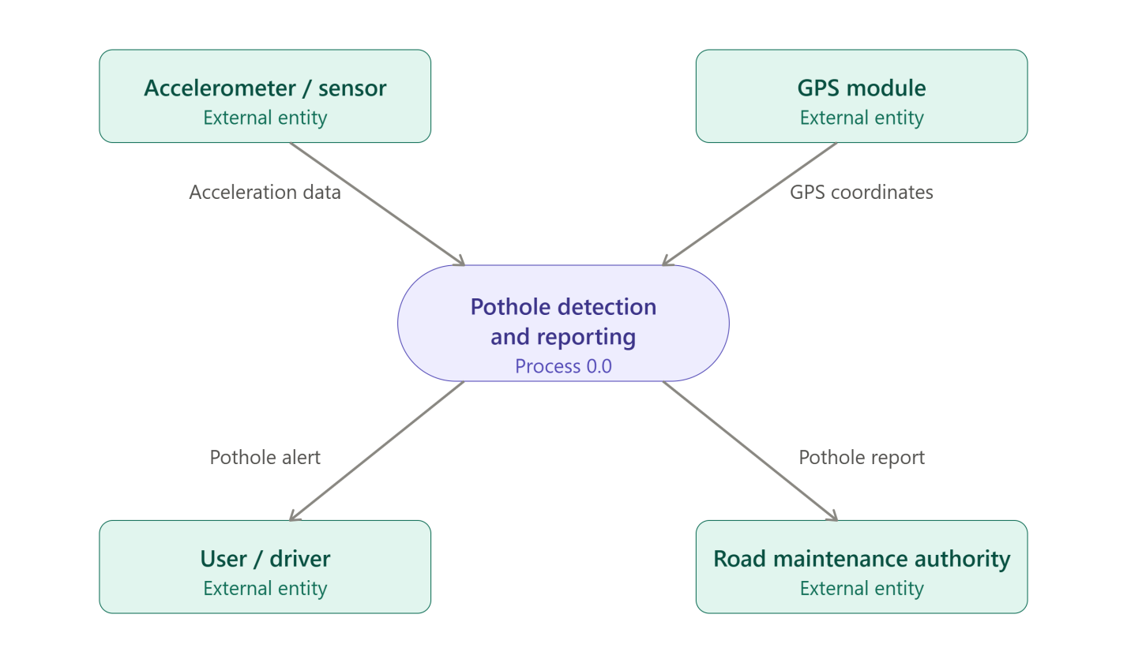

2. Level-0 DFD
The Level-0 DFD decomposes the complete Pothole Detection System into major processes.

Major Processes:
1.0 Collect Sensor Data
Collects acceleration values from the accelerometer and GPS coordinates from the GPS module.
2.0 Process Sensor Data
Processes and analyzes the collected acceleration values.
3.0 Detect Pothole
Determines whether the processed sensor values indicate a pothole.
4.0 Store Pothole Information
Stores detected pothole information, including location and sensor data.
5.0 Generate/Display Report
Provides pothole information to the user or road maintenance authority.

Data Stores:
D1 – Sensor Data Store
Stores collected sensor readings.
D2 – Pothole Database
Stores detected pothole information.

3. Level-1 DFD
The Level-1 DFD provides a more detailed decomposition of the main processes. For the Pothole Detection System, the Pothole Detection Process (3.0) can be further divided into smaller processes.

Sub-processes:
3.1 Read Acceleration Values
Reads X-axis, Y-axis, and Z-axis acceleration values.
3.2 Calculate/Analyze Acceleration
Analyzes the acceleration values to identify abnormal changes or vibrations.
3.3 Apply Pothole Detection Logic
Compares the processed acceleration data with the required detection condition/threshold.
3.4 Confirm Pothole
Determines whether the detected abnormal vibration represents a pothole.
3.5 Obtain GPS Location
Gets the latitude and longitude associated with the detected pothole.
3.6 Create Pothole Record
Combines pothole detection information, GPS coordinates, and sensor data into a pothole record.

Level-0 DFD Representation
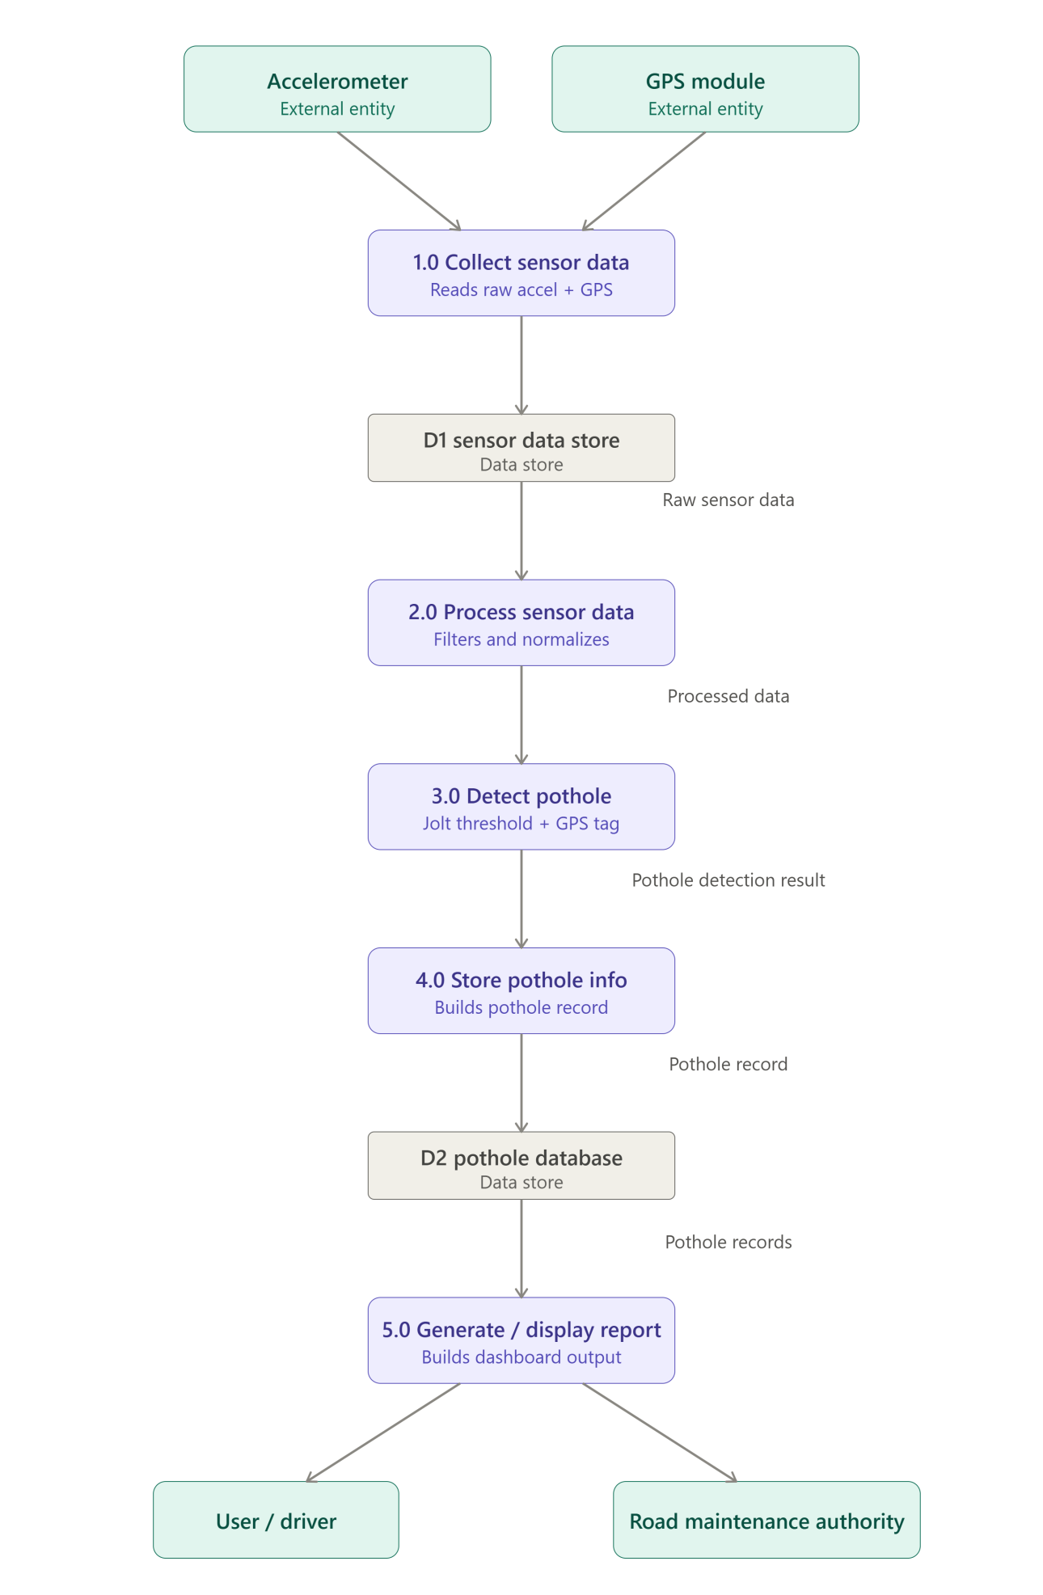

Level-1 DFD Representation

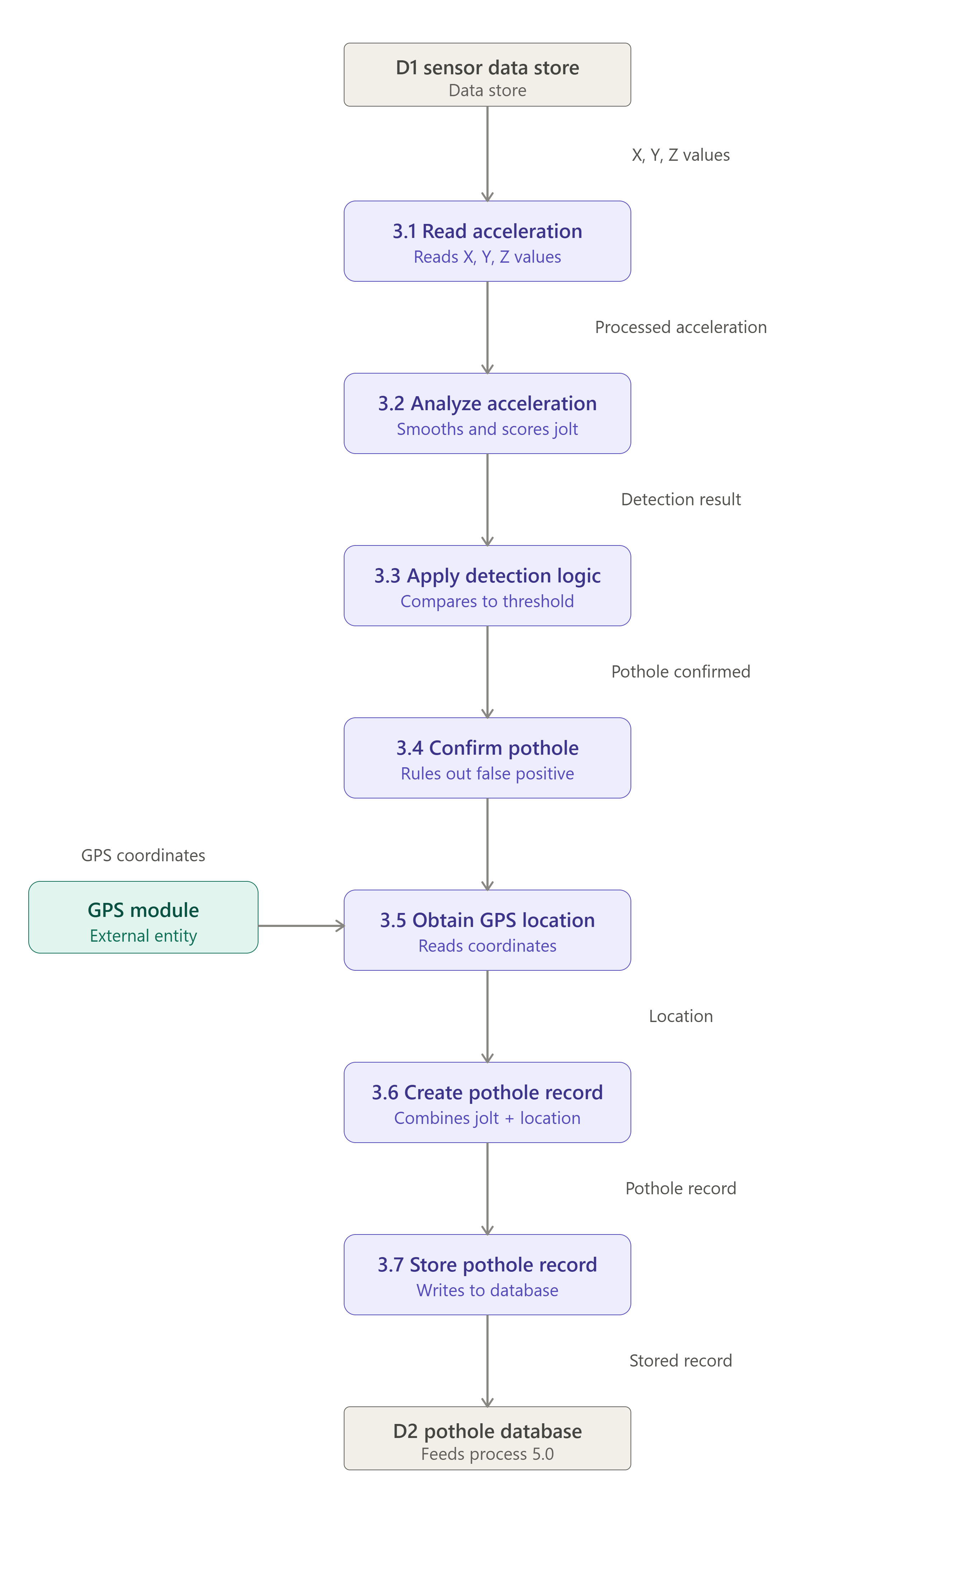

Data Dictionary
A Data Dictionary describes the data used by the system.
Data Name | Description
Acceleration Data | X-axis, Y-axis and Z-axis acceleration readings
GPS Coordinates | Latitude and longitude of the detected location
Processed Data | Sensor data after analysis
Detection Result | Indicates whether a pothole is detected
Pothole Location | Geographical location of detected pothole
Pothole Record | Complete information about a detected pothole
Pothole Report | Report containing pothole locations and details
Sensor Data | Raw data received from sensors

Functional Requirements
- The system shall collect acceleration data from the accelerometer.
- The system shall obtain geographical coordinates from GPS.
- The system shall process the acceleration readings.
- The system shall identify abnormal acceleration patterns.
- The system shall determine whether a pothole is detected.
- The system shall record the location of the detected pothole.
- The system shall store detected pothole information.
- The system shall allow the user to view pothole information.\
- The system shall generate pothole reports.
- The system shall provide useful information for road maintenance.

Non-Functional Requirements

1. Accuracy
The system should accurately detect potholes and record their locations.

2. Reliability
The system should operate reliably while collecting sensor and GPS data.

3. Performance
The system should process sensor readings with minimum delay.

4. Usability
The system interface should be simple and easy to understand.

5. Maintainability
The software should be easy to update and maintain.

6. Scalability
The system should support increasing numbers of pothole records and users.

DFD Balancing
DFD balancing means that the data entering and leaving a process at one level should remain consistent when the process is decomposed into a lower level.
For the Pothole Detection System:

Context Diagram
Input:
- Acceleration Data
- GPS Coordinates
Output:
- Pothole Detection Result
- Pothole Location
- Pothole Report

Level-0
These same major inputs and outputs are represented through processes such as:
- Collect Sensor Data
- Process Sensor Data
- Detect Pothole
- Store Information
- Generate Report
Therefore, the Level-0 DFD is balanced with the Context Diagram.

Level-1
The Detect Pothole process is further decomposed into:
- Read Acceleration Values
- Analyze Acceleration
- Apply Detection Logic
- Confirm Pothole
- Obtain GPS Location
- Create Pothole Record
- Store Pothole Record
The inputs and outputs remain consistent with the parent process.

Advantages of SSAD for Pothole Detection System
- Provides a clear understanding of the pothole detection process.
- Clearly identifies sensor and GPS inputs.
- Shows how sensor data moves through the system.
- Helps identify required data stores.
- Reduces ambiguity in system requirements.
- Makes complex processes easier to understand.
- Improves communication between developers and users.
- Helps identify missing requirements.
- Provides a foundation for software design.
- Helps in planning testing and implementation

Applications
The Pothole Detection System can be used in:
- Smart City projects.
- Road maintenance systems.
- Municipal corporation road monitoring.
- Highway monitoring.
- Transportation management systems.
- Smart vehicle applications.
- Road quality monitoring.
- Government infrastructure management.
- Public road safety systems.
- Geographic road-condition mapping.

Conclusion
Structured Systems Analysis and Design provides a systematic method for analyzing the Pothole Detection and Reporting System. Using SSAD techniques, the system requirements, external entities, processes, data flows, and data stores can be clearly identified.
The Context Diagram represents the complete system, while the Level-0 DFD represents its major processes. The Level-1 DFD further decomposes the pothole detection process into smaller and more understandable activities.
The DFDs show how acceleration data is collected from the sensor, GPS coordinates are obtained, sensor values are analyzed, potholes are detected, and the resulting information is stored and reported. Thus, SSAD provides a strong foundation for designing and implementing the Pothole Detection System.

FAQs

1. What are the main tools used in SSAD?
The main tools used in SSAD are Data Flow Diagrams (DFDs), Context Diagrams, Data Dictionaries, Decision Tables, Decision Trees, and Structured English.
For the Pothole Detection System, DFDs are mainly used to represent the flow of sensor data, GPS data, pothole information, and reports.

2. Why do we use DFDs?
DFDs are used to visually represent how data moves through a system.
In the Pothole Detection System, DFDs show how acceleration data is collected, processed, analyzed, combined with GPS coordinates, stored in the database, and provided as pothole information or reports.

3. What is the difference between Context Diagram and Level-0 DFD?
A Context Diagram represents the complete Pothole Detection System as a single process. It shows only the major external entities and the data flowing between them.
A Level-0 DFD divides the system into its major processes such as:
• Collect Sensor Data
• Process Sensor Data
• Detect Pothole
• Store Pothole Information
• Generate/Display Report
The Level-0 DFD also introduces the system's data stores.

4. Why should a system analyst understand the business process before drawing any diagrams?
A system analyst should understand the process before drawing diagrams because it helps correctly identify the inputs, outputs, processes, external entities, and data stores.
In the Pothole Detection System, the analyst must understand how acceleration data is collected, how potholes are detected, how GPS coordinates are obtained, and how the detected pothole information is stored and reported. This helps create accurate DFDs and prevents missing or unnecessary processes.

Result
The Structured Systems Analysis and Design (SSAD) of the Pothole Detection and Reporting System was successfully performed. The Context Diagram, Level-0 DFD, and Level-1 DFD were developed to represent the flow and processing of sensor and GPS data within the system.

